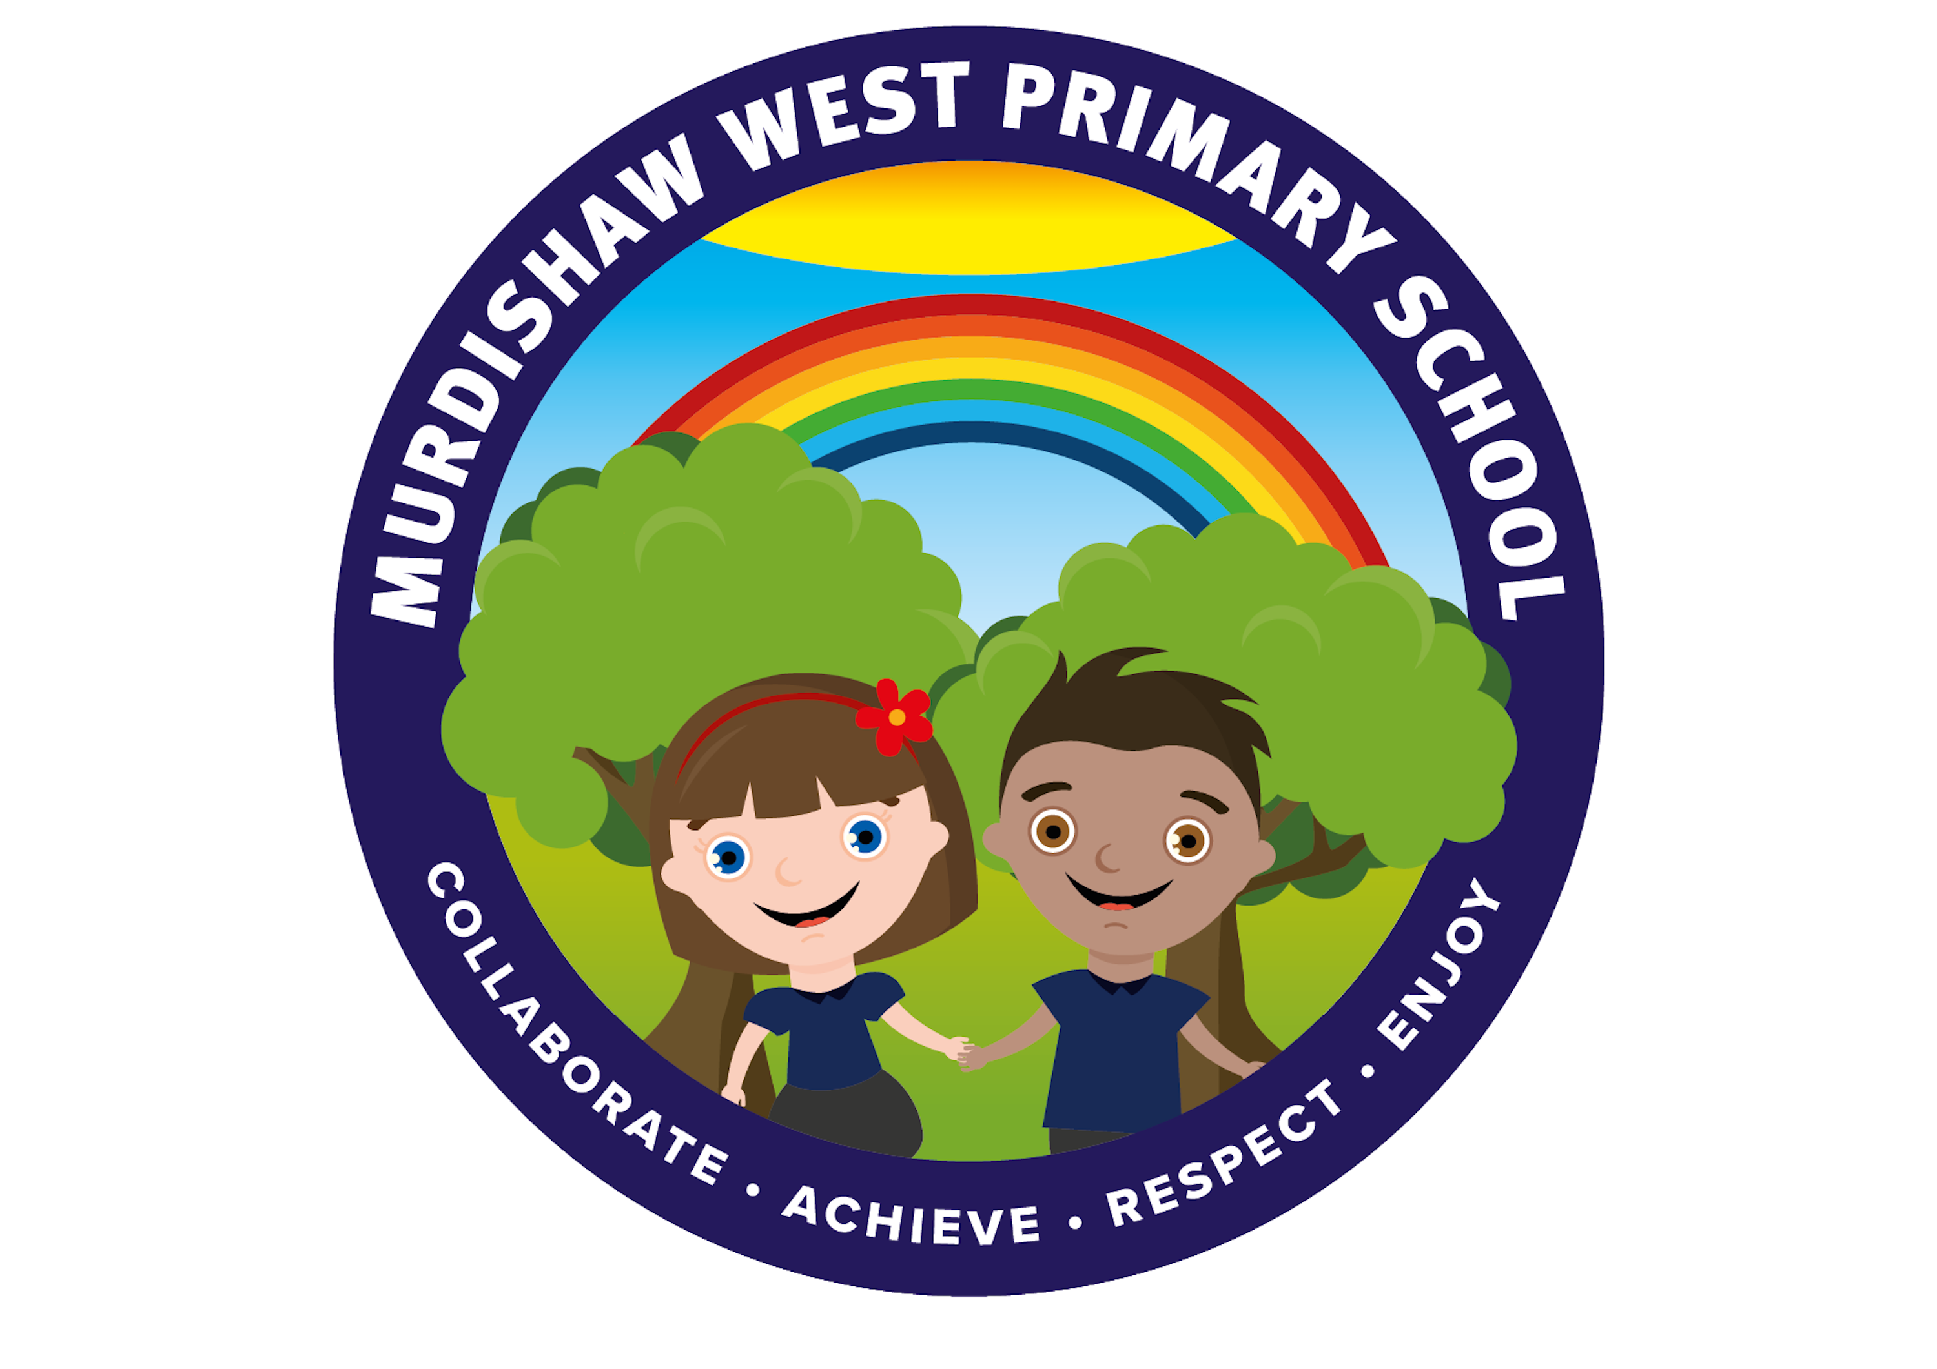 |  | MURDISHAW WEST COMMUNITY  PRIMARY SCHOOL  EARLY READING POLICY  AUTUMN 2024

Policy Title | Early Reading Policy
School/HBC | School
This policy complies with Halton LA guidance | Yes
Linked Polices & Documents | English  Reading
Written By | Vanessa Edwards/Julie Phillips
Staff Approval Date | September 2024
Committee Approval Date | September 2024
FGB Ratification Date | September 2024
Signed by Chair of Governors
Date:
Review Date | Autumn 2024

At Murdishaw West Community Primary School we work together to….. Collaborate, Achieve, Respect and Enjoy. At Murdishaw West, we CARE!

Early Reading Policy
Intent
Every child deserves reading success right from the start. We know that the sooner children learn to read, the greater their success at school. This is why we put reading at the heart of what we do. We also know that to have the highest chance of success in reading, children need to learn to read from books with the sounds they know. With this in mind, all children are given books that carefully match their phonic reading ability according to the ‘Essential Letters and Sounds’ programme.

Implementation
At Murdishaw West Primary, we teach children to read by following a phonics programme called ‘Essential Letters and Sounds’ (ELS). This programme ensures we follow a systematic and consistent approach to the teaching of phonics across each year group. Phonics lessons are taught daily at 9.00am from Reception to Year 2. We have a ‘keep up not catch up’ approach to phonics and so only a few identified children do not access this whole class session. These identified children follow a personalised learning programme instead. Children at risk of falling behind in whole class teaching are identified and these children receive additional, daily teaching. This additional teaching allows children to consolidate the mornings learning and immediately address any misconceptions observed.
The ‘Essential Letters and Sounds’ programme sets out a detailed and systematic programme for teaching phonic skills to children, with the aim of them becoming fluent readers. Children experience the same classroom routines within each ELS lesson which reduces cognitive load and maximises the chances of success. All children are supported within the lesson to use their new phonic knowledge independently, and in all ELS lessons children will make the direct application to reading.
Children are taught using the following phase progression:
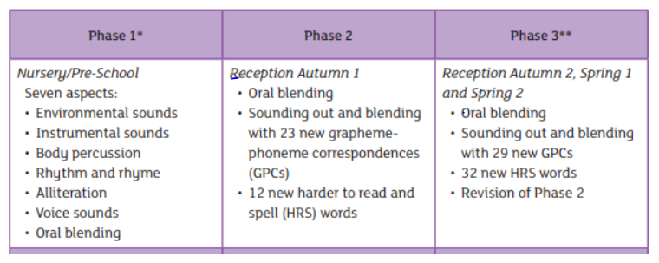
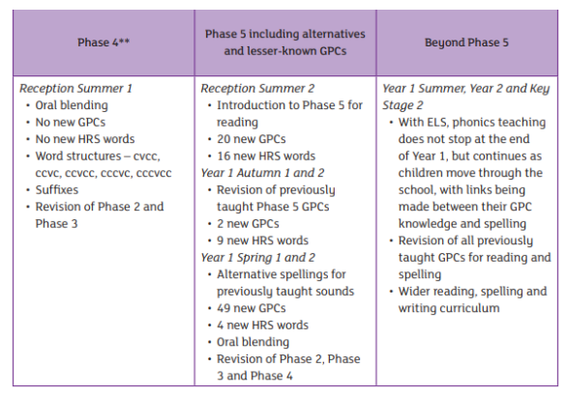

Children are taught to read using the Essential Letters and Sounds programme phase 2 as soon as they enter our Reception Class. Children learn to use and apply their phonic knowledge by reading books that match their phonic ability. Children are also taught to read high-frequency ‘harder to read’ words.
Children’s progress in developing and applying their phonic knowledge is carefully assessed and monitored. By the end of our Foundation Stage, children are expected to be working within Phase 5. By the end of Year One, the expectation is for children to be secure in, and working beyond, Phase 5.
In Year One, the children complete the National Phonics Screening Check – a statutory assessment that was introduced in 2012 for all Year One pupils. It comprises a list of 40 real words and nonsense words that assess phonics skills and knowledge learnt through our Foundation Stage and Year One. The check is very similar to tasks that the children already complete during phonics lessons. Phonics teaching continues in Year 2 for children who have not met the phonics standard for Year One. These children receive daily intervention in order to meet the standard at the end of Year Two.
At Murdishaw West Primary, guided reading sessions across the entire school are carried out as a whole class, where all children are exposed to a range of texts. Our teachers plan interactive reading lessons where there is an element of shared reading; engagement with the text; teacher modelling interrogation of the text and exploration of their own inferences. There is always opportunity for open discussion and an independent element when responding to direct questions based on the focus text for that lesson. We find this approach allows for all children to develop their comprehension and inference skills, whilst not being held back because of their decoding ability. Through creative approaches to texts, children are fully immersed in quality literature and so find reading enjoyable.
Parents are kept informed of their child’s personal reading targets through communication in their home/school reading books. Parents are also informed of their child’s whole class reading objectives through the weekly homework sheet.

Essential Letters and Sounds Term by Term Progression Map:
